/*
* file: assignments.pdf
*
* author: Michal Tešnar <michal.tesnar007@gmail.com>
*
* Description: This file contains solutions of exercises to what if questions.
*/

1. (c)
correctly scanf("%c", &x);

2. (c)
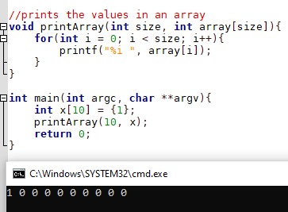
3. (d)

4. (b)

